“Property finder”

Project Report submitted for the partial fulfilment of grade for the course

Data Structures and Algorithms -3 (25CS2103E)

in

DEPARTMENT OF COMPUTER SCIENCE ENGINEERING

by

T. JASWANTH REDDY : 2520030284

V. NITISH SRI SAI : 2520030179

V. SATISH CHANDRA : 2520030302

Team Number:
Section: 9

Under the Guidance of

Dr. S. Vinay Kumar
Associate Professor
Department of Computer Science and Engineering





2026-27

DEPARTMENT OF COMPUTER SCIENCE ENGINEERING

Declaration

The Project Report entitled “Property finder” is a record of Bonafide work of
T. JASWANTH REDDY – 2520030284, V. NITISH SRI SAI – 2520030179, V. SATISH CHANDRA – 2520030302 submitted in partial fulfillment for the award of B. Tech in Computer Science and Engineering. The results embodied in this report have not been copied from any other departments/University/Institute.

T. JASWANTH REDDY – 2520030284
V. NITISH SRI SAI – 2520030179
V. SATISH CHANDRA – 2520030302

DEPARTMENT OF COMPUTER SCIENCE ENGINEERING

CERTIFICATE

This is certify that the mini project based report entitled “Property finder” is a bonafide work done and submitted by T. JASWANTH REDDY – 2520030284, V. NITISH SRI SAI – 2520030179, V. SATISH CHANDRA – 2520030302 in partial fulfillment of the requirements for the award of the degree of BACHELOR OF TECHNOLOGY in Department of Computer Science Engineering, during the academic year 2026-27.

Signature of the Guide Signature of the HOD
(Dr. S. Vinay Kumar)

Signature of the External Examiner
ACKNOWLEDGEMENT

We would like to express our sincere gratitude to our project guide, Dr. S. Vinay Kumar, Associate Professor, Department of Computer Science and Engineering, for his valuable guidance, encouragement, and continuous support throughout the development of the Property Finder project.
We also express our sincere thanks to Dr. P. Venkateshwara Rao, Associate Professor and Head of the Department of Computer Science and Engineering, for providing us with the required academic environment and facilities to complete this project successfully.
We are grateful to the Department of Computer Science and Engineering for providing the opportunity to apply the concepts of Data Structures and Algorithms to a practical real-world problem.
Finally, we thank our team members, classmates, and everyone who supported us during the design, implementation, testing, and documentation of this project.

T. JASWANTH REDDY – 2520030284
V. NITISH SRI SAI – 2520030179
V. SATISH CHANDRA – 2520030302

Abstract

The Property Finder project is a property search and discovery system designed to help users efficiently find suitable properties from a collection of property records. Real estate platforms may contain a large number of property listings, making manual searching difficult and time-consuming. Users commonly search properties using criteria such as location, price, property type, BHK, area, amenities, rating, and availability.
The core of the project is a Java-based text corpus search system. Property information is stored as text documents in a corpus, and the system searches these documents for user-entered patterns. The main DSA search implementation uses the Knuth-Morris-Pratt (KMP) pattern matching algorithm, which uses the Longest Proper Prefix which is also Suffix (LPS) array to avoid unnecessary character comparisons.
The project also contains a web-based Property Finder interface implemented using HTML, CSS, JavaScript, and Node.js with Express. The website provides a user-friendly interface for browsing properties, applying filters, viewing property details, shortlisting properties, and comparing selected properties.
The project repository also contains implementations and demonstrations of additional Data Structures and Algorithms concepts, including string algorithms, dynamic programming, graph and flow algorithms, approximation techniques, randomized algorithms, and parallel-processing-related algorithms. These components provide an extended DSA environment for academic demonstration and evaluation.
Overall, the Property Finder project demonstrates how algorithmic techniques can be applied to a practical real-estate search problem while combining a Java DSA implementation with a modern web interface.

Table of Contents

 |  |  | Page No.
 | Acknowledgement
 | Abstract
 | Table of Contents
 | List of Figures
1 | Introduction | 1.1 Overview  1.2 Problem statement  1.3 Scope of the project  1.4 Objectives | 5-15
2 | System Requirements | 2.1 Functional Requirements  2.2 Non-Functional Requirements | 16-21
3 | System Design | 3.1 High-level Architecture Diagram  3.2 Description of each layer | 33-36
4 | Implementation | 4.1 Module-wise implementation  4.2 Front-end logic (UI rendering, state management)  4.3 API integration  4.4 ……. | 38-47
5 | Results |  | 56-64
6 | Challenges & Limitations | 6.1 Issues faced during development  6.2 Solutions applied  6.3 Limitations of the System | 74-82
7 | Conclusion & Future Work | 7.1 Conclusion  7.2 Future Work  7.3 Skills learned during development | 89-97
 | References | - Books, tutorials, APIs, documentation sites used | 98-99

List of Figures

1.1 Property Finder System Architecture
1.2 Property Search Workflow
1.3 Property Corpus Structure
1.4 KMP Pattern Matching Process
1.5 LPS Array Construction
1.6 Property Search Result Interface
1.7 Property Details Interface
1.8 Property Filtering Interface
1.9 Property Comparison Interface
1.10 Property Shortlist Interface

- INTRODUCTION

1.1 Overview
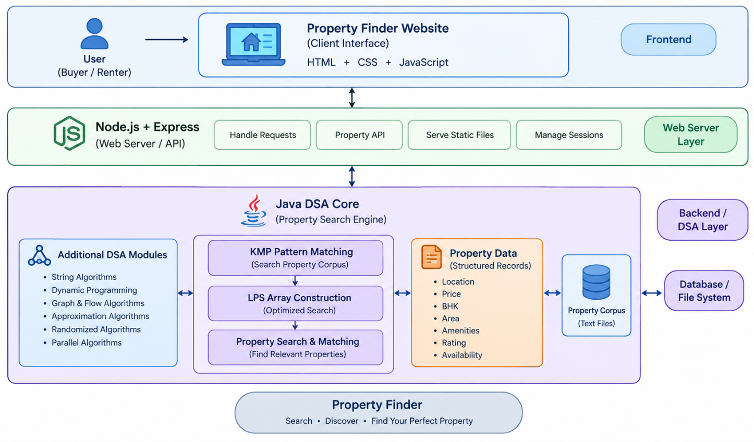
Fig. 1.1 Architecture of Cloud
Real-estate websites contain a large number of property listings with different locations, prices, property types, BHK configurations, areas, amenities, ratings, and availability conditions. Finding a suitable property manually from a large collection of records can be difficult and time-consuming.
The Property Finder project addresses this problem by providing an algorithm-based property search system. The project stores property information in a text corpus and allows users to search for relevant information using keywords or patterns.
The primary DSA component of the project is the Knuth-Morris-Pratt (KMP) pattern matching algorithm. KMP is a string-searching algorithm that improves pattern searching by using information about previously matched characters. It constructs an LPS array and uses it to skip unnecessary comparisons after a mismatch.
The project also provides a web interface through which users can browse and interact with property records. The website contains property cards, search fields, filtering options, property details, shortlisting, and comparison features.
The system therefore combines the academic implementation of DSA algorithms with a practical property-search application.

1.2 Problem Statemen
Real-estate platforms contain a large number of property records. Buyers and renters need to search these records according to their requirements such as location, price, BHK, property type, area, amenities, rating, and availability.
A simple sequential search through large text documents can become inefficient because the same characters may be compared repeatedly.
Therefore, the problem addressed by this project is:
“To design and implement an efficient property search system that applies Data Structures and Algorithms, particularly pattern matching, to search property records and provide relevant property information through a user-friendly interface.”

1.3 Scope of the Project
The scope of Property Finder includes:
- Searching property records using text patterns.
- Maintaining a property corpus containing multiple property documents.
- Searching property information using the KMP pattern matching algorithm.
- Supporting case-insensitive pattern searching.
- Displaying matching property records.
- Displaying detailed property information.
- Filtering properties based on location, type, price, BHK, area, amenities, rating, and availability.
- Shortlisting properties.
- Comparing selected properties.
- Providing a web-based interface.
- Demonstrating additional DSA algorithms available in the project repository.
1.4 Objectives
The main objectives of the project are:
- To develop a practical property search application.
- To represent property information using a text corpus.
- To implement pattern searching using KMP.
- To reduce unnecessary character comparisons during pattern matching.
- To support property discovery using multiple search criteria.
- To provide detailed property information to users.
- To provide filtering, shortlisting, and comparison facilities.
- To develop a responsive and user-friendly web interface.
- To demonstrate the practical application of Data Structures and Algorithms.
- To provide a foundation for future intelligent property recommendation features.

RESULTS

1 Java Search Results
The Java application successfully searches the property corpus using user-entered patterns.
For example, when a user enters a location such as Hyderabad, the program searches each property document and displays the files containing the requested pattern.
Similarly, entering an amenity such as parking searches the property documents for occurrences of the word.
If no property contains the entered pattern, the program displays:
No matching properties found

2 Website Results
The web interface displays property records in an organized card-based layout.
Each property card provides:
- Property name
- Location
- Price
- BHK
- Area
- Property type
- Rating
- Availability
- Amenities
- Description
The user can select individual properties to obtain additional information.
Conclusion
The Property Finder project demonstrates the application of Data Structures and Algorithms to a practical real-world property-search problem.
The core Java implementation uses the KMP pattern matching algorithm to search property documents stored in a text corpus. The use of the LPS array allows the search algorithm to avoid unnecessary comparisons and provides an efficient approach to pattern searching.
The project also includes a web-based Property Finder interface using HTML, CSS, JavaScript, Node.js, and Express. The website allows users to browse properties, search and filter listings, view property details, shortlist properties, and compare multiple properties.
The project therefore combines algorithmic problem solving with a practical user interface and demonstrates how DSA concepts can be applied to real-world information retrieva

Limitations of the System
The current system has some limitations:
- The property corpus is file-based rather than database-based.
- Property information is based on project data rather than live real-estate listings.
- The current system does not provide real-time property availability.
- User authentication is not implemented.
- Online property booking or payment is not implemented.
- Advanced personalized recommendation is not fully implemented.
- The website and Java DSA implementation are separate application layers rather than a fully integrated Java-backend web service.
- Large-scale production deployment would require a database and indexed search system.

REFERENCES
• Thomas H. Cormen, Charles E. Leiserson, Ronald L. Rivest, and Clifford Stein, Introduction to Algorithms, MIT Press.
• Robert Lafore, Data Structures and Algorithms, Pearson.
• Oracle Java Documentation, Java Platform Documentation.
• Node.js Documentation, Node.js Runtime Documentation.
• Express.js Documentation, Express Web Framework Documentation.
• Donald E. Knuth, James H. Morris Jr., and Vaughan R. Pratt, Fast Pattern Matching in Strings, SIAM Journal on Computing.
• Project source code and property corpus developed as part of the Property Finder project.

